**Friends Bakery Management System (FBMS)**

**Table of Contents**

1. [Introduction](https://github.com/shivasayishesshank/Friends-Bakery-Management-System-G8/blob/main/?tab=README.md#introduction)
2. [What is FBMS?](https://github.com/shivasayishesshank/Friends-Bakery-Management-System-G8/blob/main/?tab=README.md#What-is-FBMS)
3. [Architecture](https://github.com/shivasayishesshank/Friends-Bakery-Management-System-G8/blob/main/?tab=README.md#Architecture)
4. [FBMS Usage](https://github.com/shivasayishesshank/Friends-Bakery-Management-System-G8/blob/main/?tab=README.md#FBMS-Usage)
5. [Project Demo](https://github.com/shivasayishesshank/Friends-Bakery-Management-System-G8/blob/main/?tab=README.md#Project-Demo)

**1. introduction :**

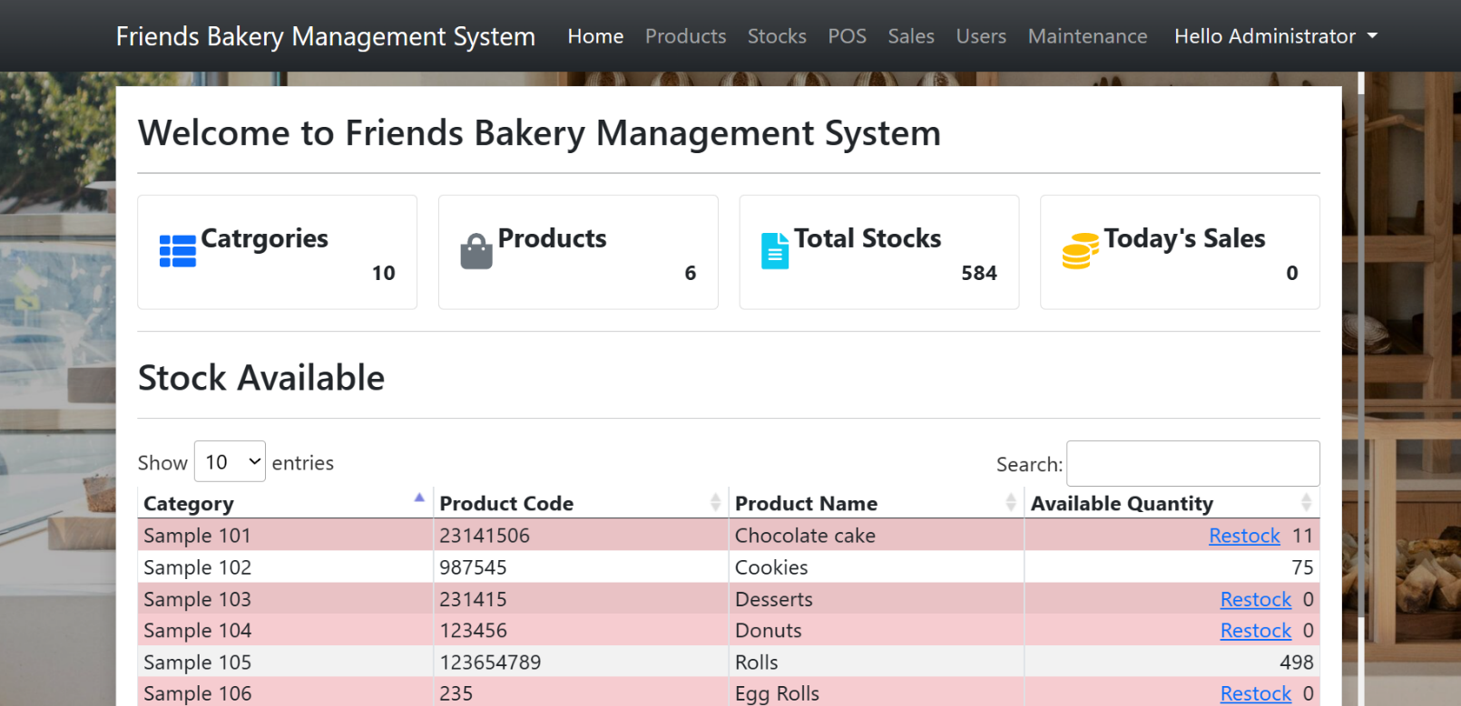In this section, we briefly introduce the Friends Bakery Management System and its importance in streamlining bakery operations. A Friends Bakery Management System is a software solution that simplifies and automates numerous parts of bakery operations. It combines inventory management, sales tracking, order processing, billing, customer relationship management, and reporting into a one platform. A FBMS uses technology to simplify bakery management, increase operational efficiency, and improve customer service.

**2. What is FBMS?**

Friends Bakery Management System is a software solution specifically designed for bakeries, including capabilities like as inventory management, sales tracking, order processing, billing, customer relationship management, and reporting, among others. The system may be customised to match the specific demands and requirements of bakery firms, allowing them to run their operations more efficiently and effectively.

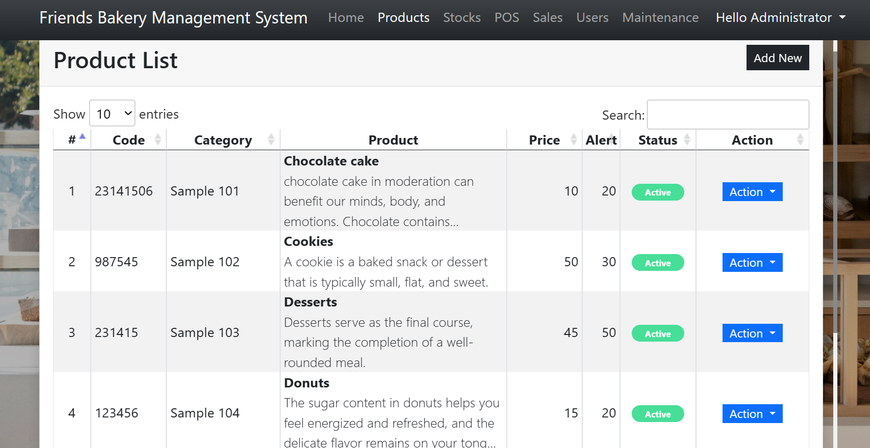**Image of Product list in Friends Bakery Management System :**

**3. Architecture of FBMS :** Friends Bakery Management System offer a wide range of features to help with bakery operations, including inventory and sales management, customer interaction, and system maintenance. Each element contributes significantly to bakery productivity, customer service, and business success.

**3.a. Home:** The bakery management system's home area is likely to serve as the dashboard or main interface, from which users can access numerous capabilities and browse to different modules. It may include an overview of critical metrics, notifications, and shortcuts to frequently used functionality.

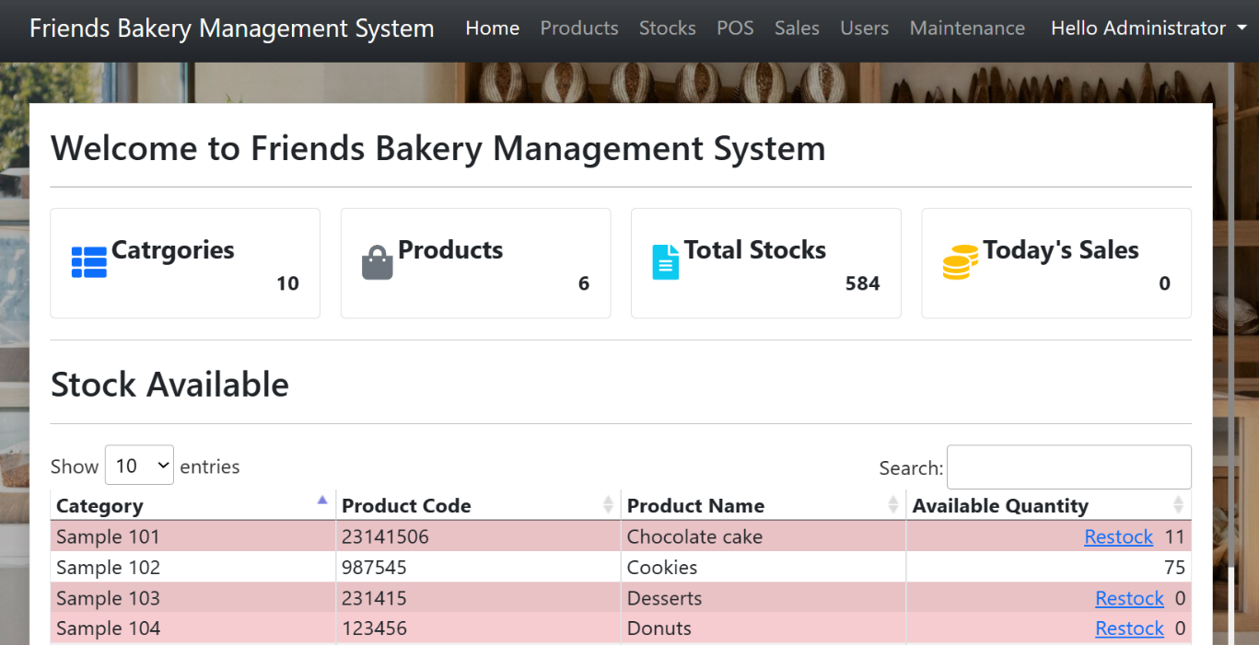

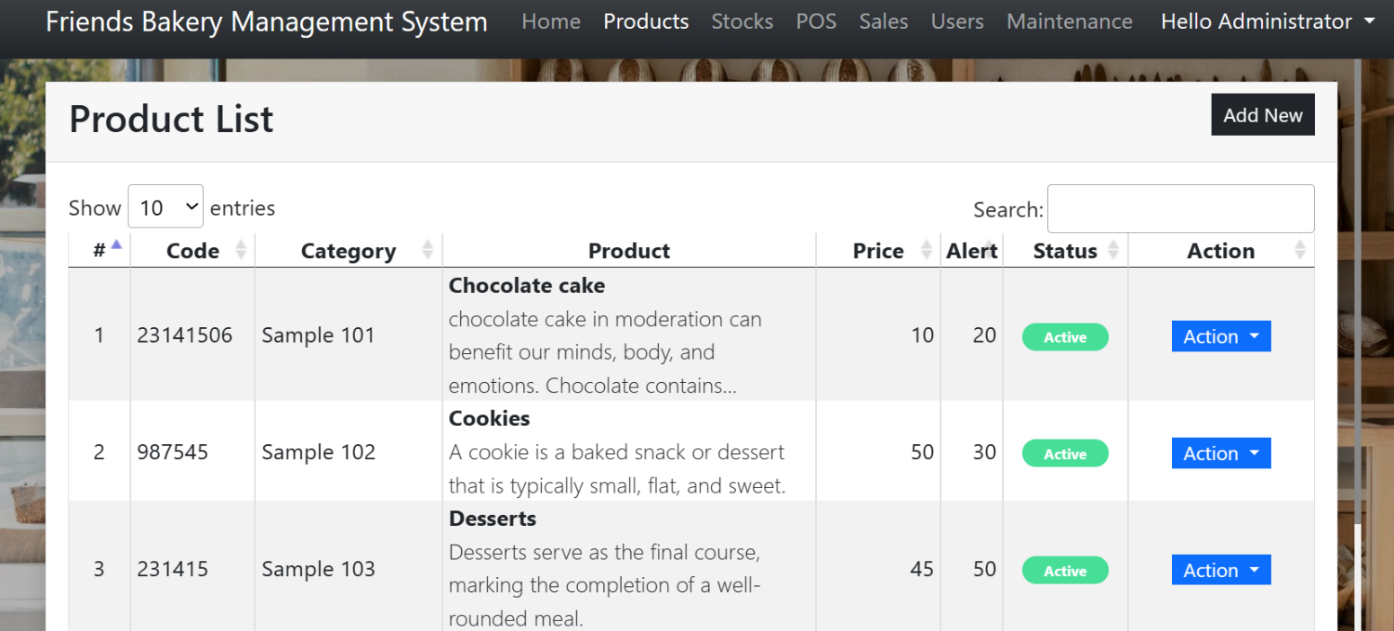**3.b. Products:** The products module enables bakery employees to manage their inventory of bakery products. It is likely to have functionality for adding new items, updating product details (such as name, description, and price), categorising products, setting stock levels, and managing product variants (for example, different flavours or sizes).

**3.c. Stocks:** The stocks module allows bakery employees to track and manage the inventory of ingredients, raw materials, and other baking supplies. It could contain tools for tracking stock levels, receiving and documenting deliveries, establishing reorder points, and creating reports on stock movements and inventory levels.

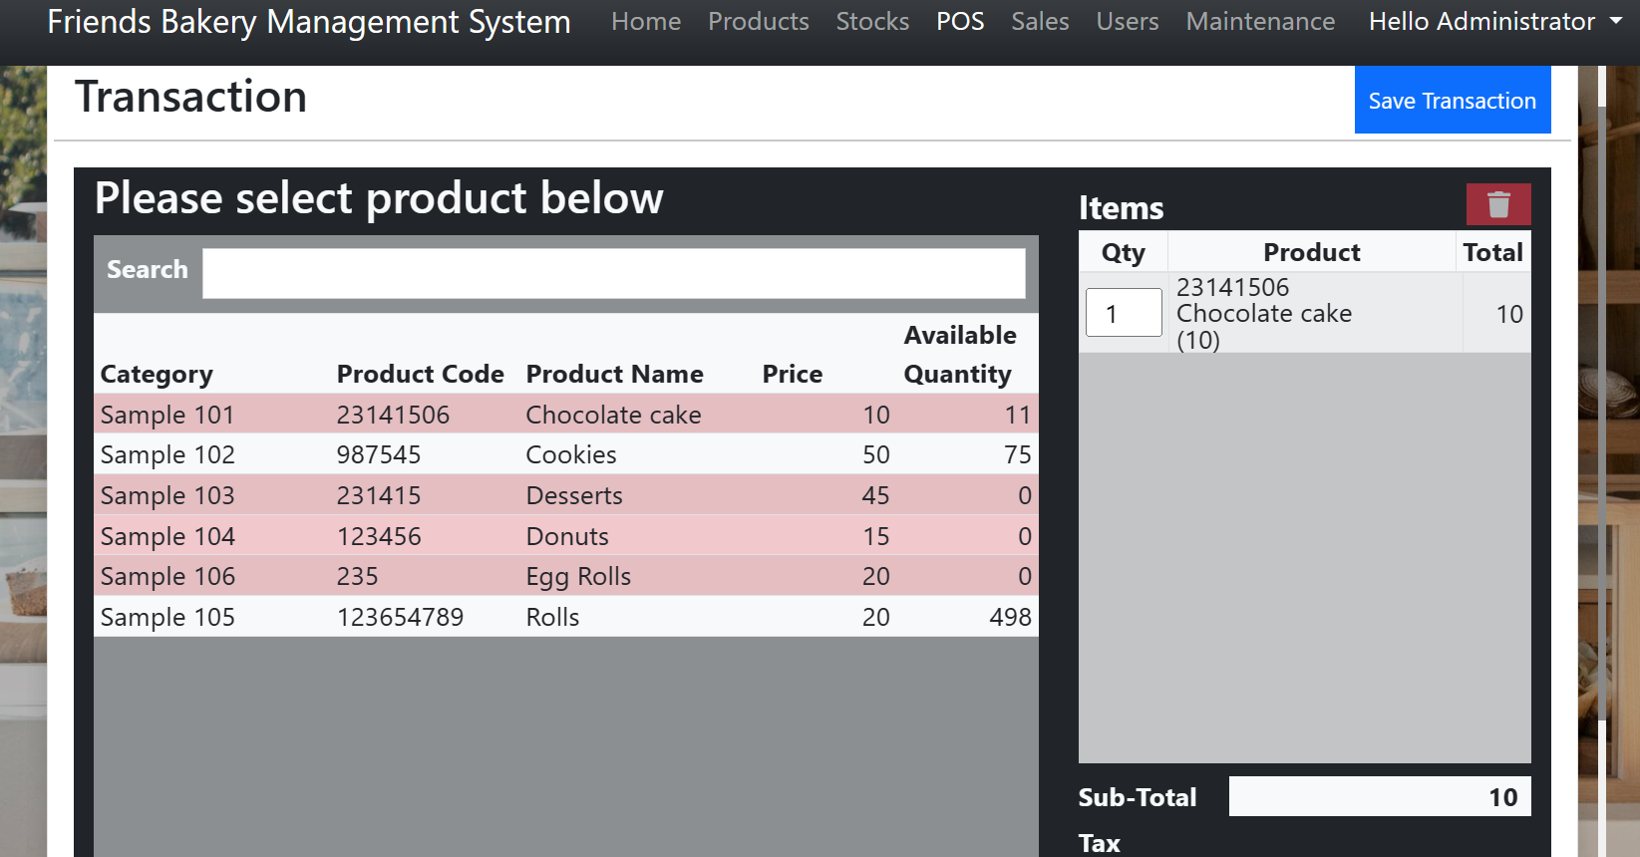

**3.d. Point of Sale (POS):** The POS module simplifies sales transactions at the bakery's physical or online location. It is likely to include tools for processing orders, accepting payments (cash, credit/debit cards, digital wallets), creating invoices or receipts, applying discounts or promotions, and handling customer interactions at the point of sale.

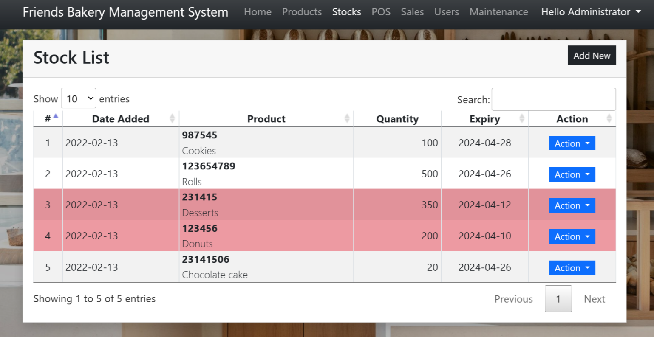

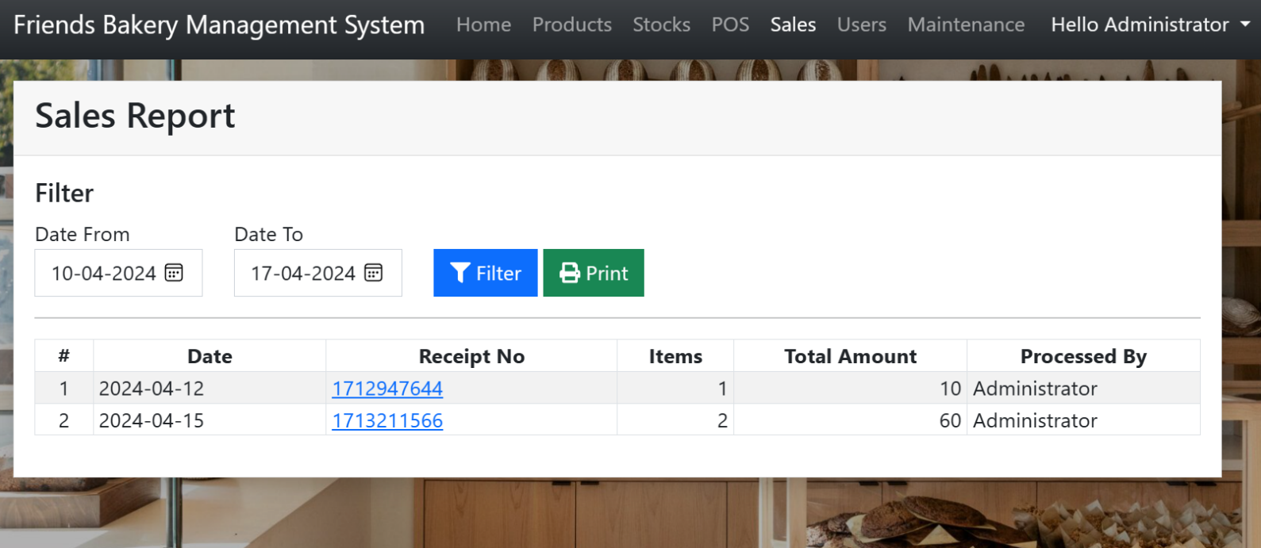**3.e. Sales:** The sales module gives information about bakery sales performance and trends. It may contain capabilities for creating sales reports, analysing sales data by product, category, or time period, finding best-selling items, and anticipating sales patterns to help with inventory management and business decisions.

**3.f. User Management:** The user management module enables bakery administrators to manage user accounts and permissions in the system. It could include capabilities for creating user profiles, assigning roles and access levels, resetting passwords, and monitoring user behaviour.

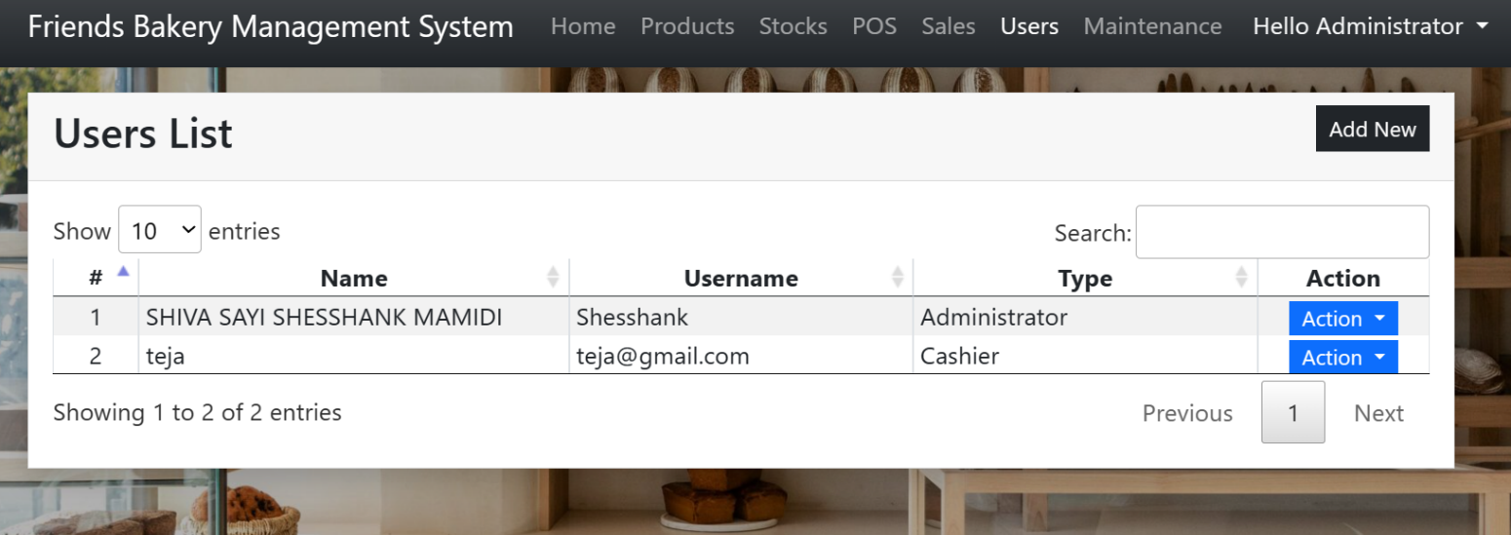

**3.g. Maintenance:** The maintenance module helps to keep the bakery management system in good working order. It could include capabilities for software updates, database backups, system configuration, and addressing technical problems.

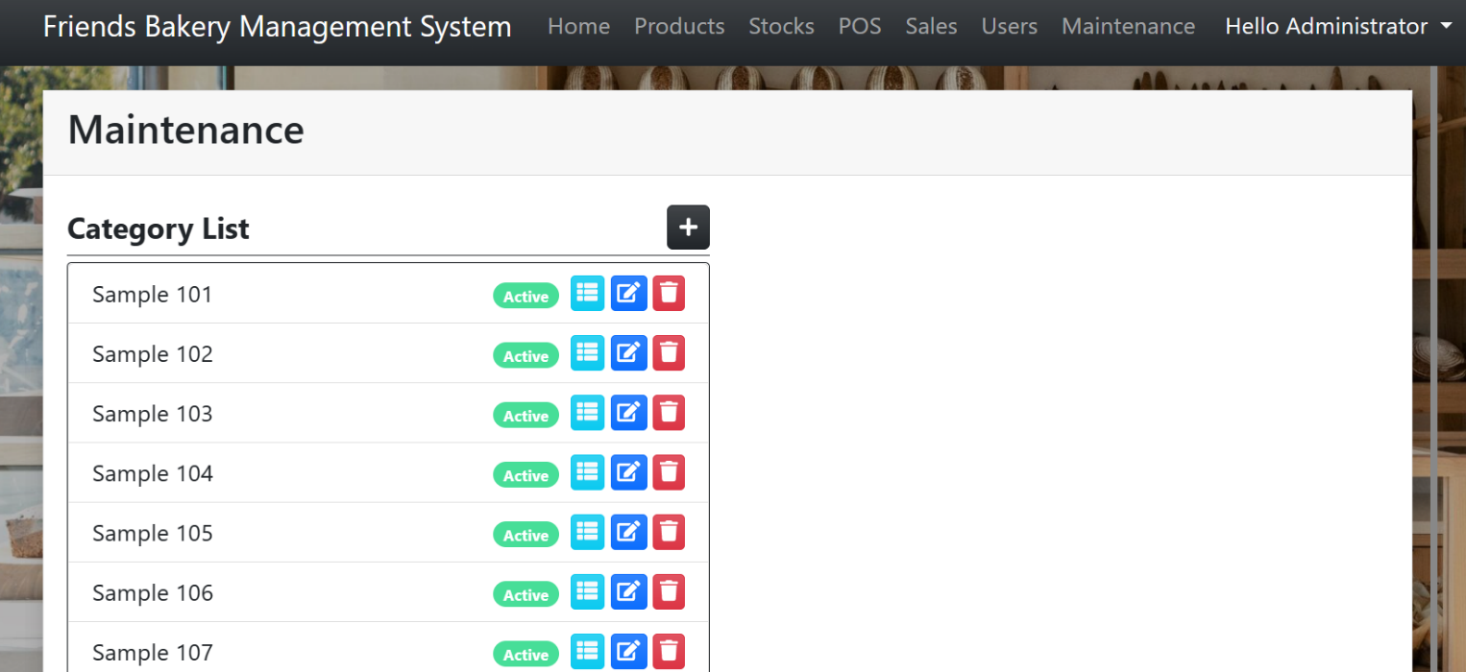

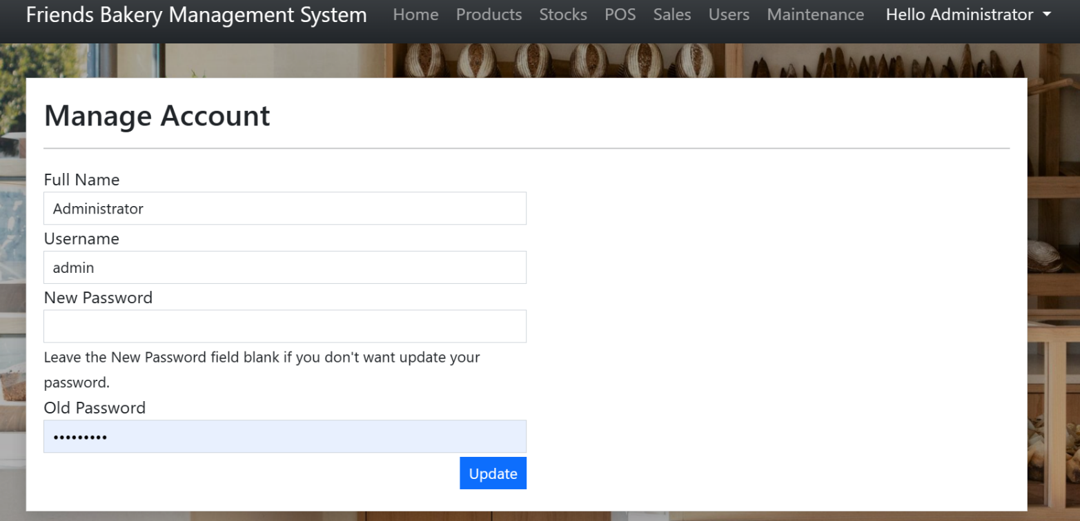**3.h. Account Manage/Signin :** Allow users to access and edit their profile information, such as altering contact information, passwords, and account preferences.

**4. FBMS Usage :**

**4.a. Installation:** FBMS is a software application, follow the installation instructions provided with the software. This may involve downloading and installing the application on your computer or server.

**4.b. Login:** If the FBMS requires user authentication, you'll typically need to log in with your username and password. Some systems may provide options for single sign-on (SSO) or other authentication methods.

**4.c. Navigation:** Once logged in, familiarize yourself with the user interface of FBMS. Navigate through the different sections or modules to access the features you need.

Common sections/modules in FBMS may include:

* Home/dashboard: Overview of bakery operations and key metrics.
* Products: Manage bakery products, including adding, editing, and deleting products.
* Inventory/Stocks: Manage inventory levels, track stock movements, and receive alerts for low stock.
* Point of Sale (POS): Process customer orders, manage payments, and generate invoices.
* Sales: View sales reports, analyse sales data, and track performance.
* Users: Manage user accounts, roles, and permissions (if applicable).
* Maintenance: Perform system maintenance tasks such as backups or updates (if applicable).

**4.d. Usage:** Use the features provided by FBMS according to your bakery's needs. For example, you can add new bakery products to the system, manage inventory levels, process customer orders at the POS, view sales reports to track performance, and manage user accounts and permissions.

**4.e. Customization:** Depending on the FBMS, there may be options for customization to tailor the system to your bakery's specific requirements. Explore any customization options available within the system.

**4.f. Support and Training:** If needed, seek support or training resources provided by the FBMS vendor or developer. This may include user manuals, documentation, tutorials, or customer support channels.

**4.g. Feedback and Improvement:** Provide feedback on your experience using FBMS. If you encounter any issues or have suggestions for improvement, communicate them to the FBMS vendor or developer. Your feedback can help improve the system for future users.

**5. Project Demo :**

<https://drive.google.com/file/d/1qci8PTzYnfi756CXgv7NZQvTrTU8QJuE/view?usp=sharing>